**Familiarizing the parts of the System**

1. System Credentials Verification Dialog (Username and Password)

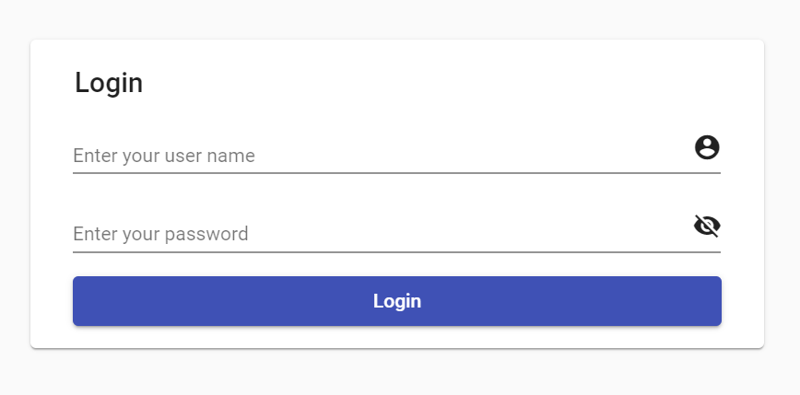

1. Menu 

This is consist of Username, Role, Location and Links

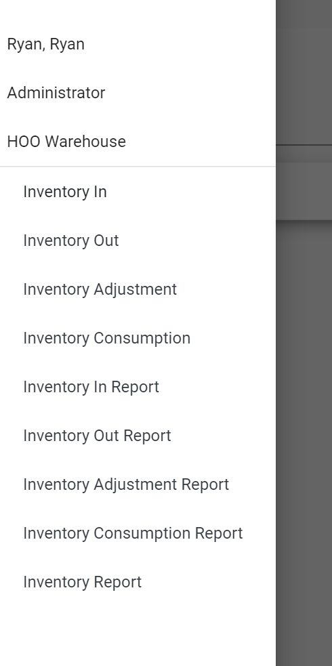

1. Inventory In

When you click the Inventory In button, a modal window will appear. Fill up the Barcode, Quantity, Expiry Date, Reference and Comment. Once finish click Save, details will appear on the table. You can filter the table rows when typing in the filter field. Click Close will close the modal window.

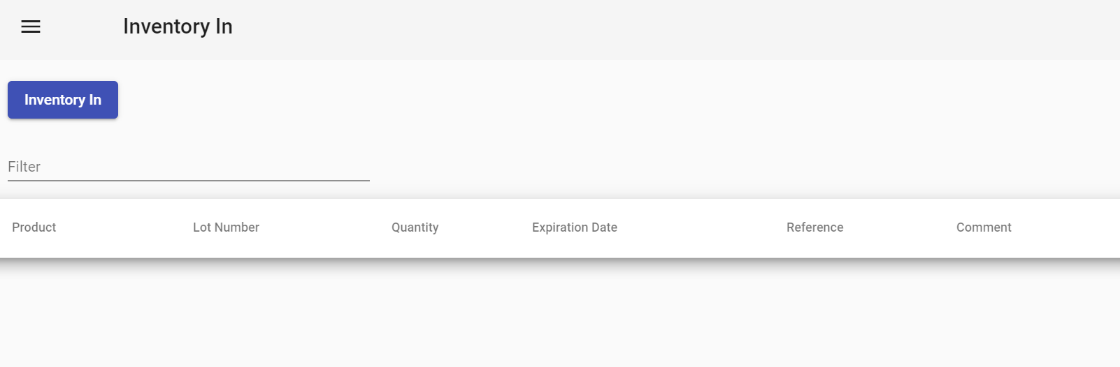

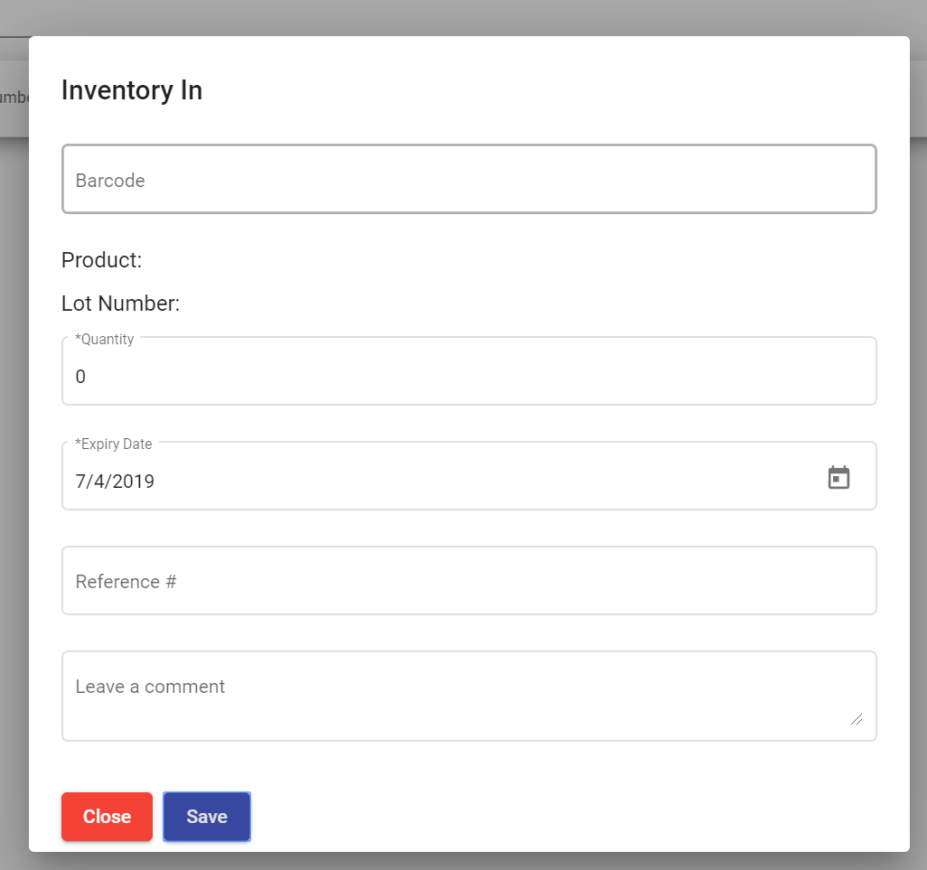

1. Inventory Out

When you click the Inventory Out button, a modal window will appear. Fill up the Barcode, Quantity, Delivered to, Reference and Comment. Once finish click Save, details will appear on the table. You can filter the table rows when typing in the filter field. Click Close will close the modal window.

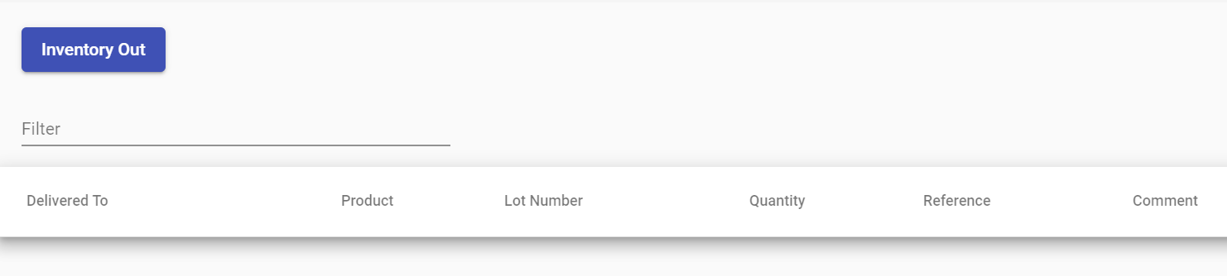

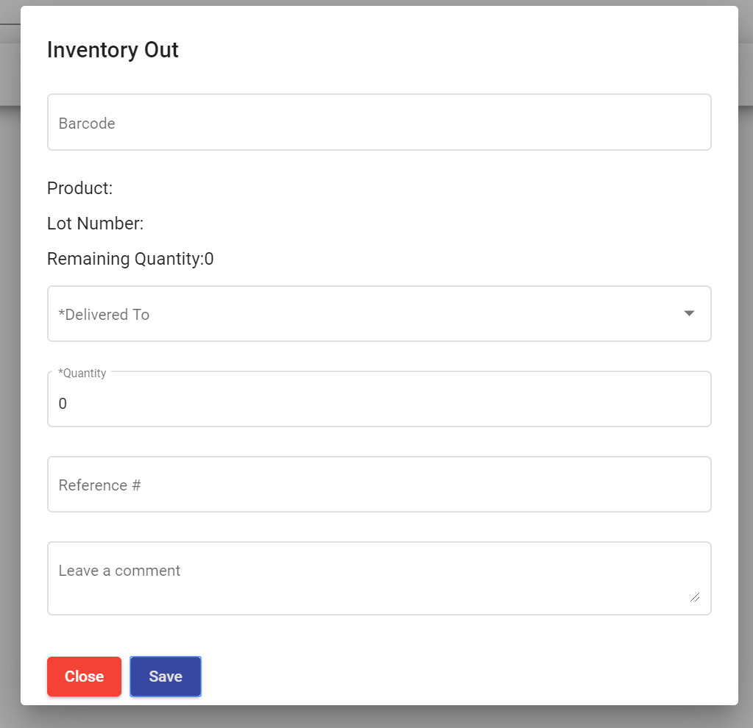

1. Inventory Adjustment

When you click the Inventory Adjustment button, a modal window will appear. Fill up the Barcode, Quantity, Reference and Comment. Once finish click Save, details will appear on the table. You can filter the table rows when typing in the filter field. Click Close will close the modal window.

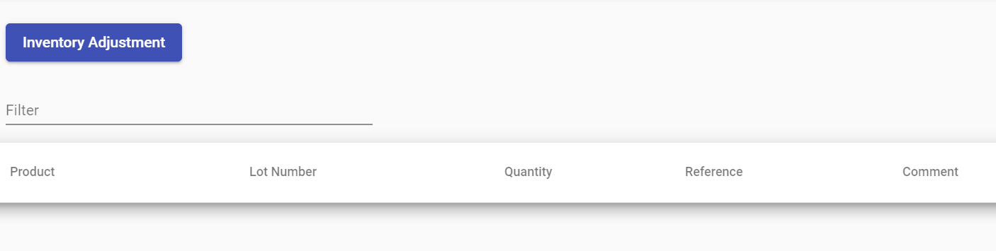

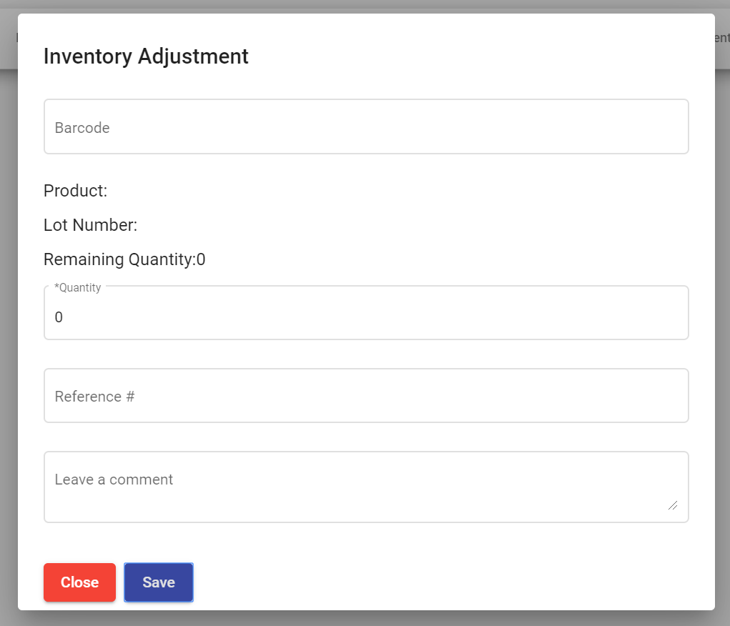

1. Inventory Consumption

When you click the Inventory Consumption button, a modal window will appear. Fill up the Barcode, Quantity, Reference and Comment. Once finish click Save, details will appear on the table. You can filter the table rows when typing in the filter field. Click Close will close the modal window.

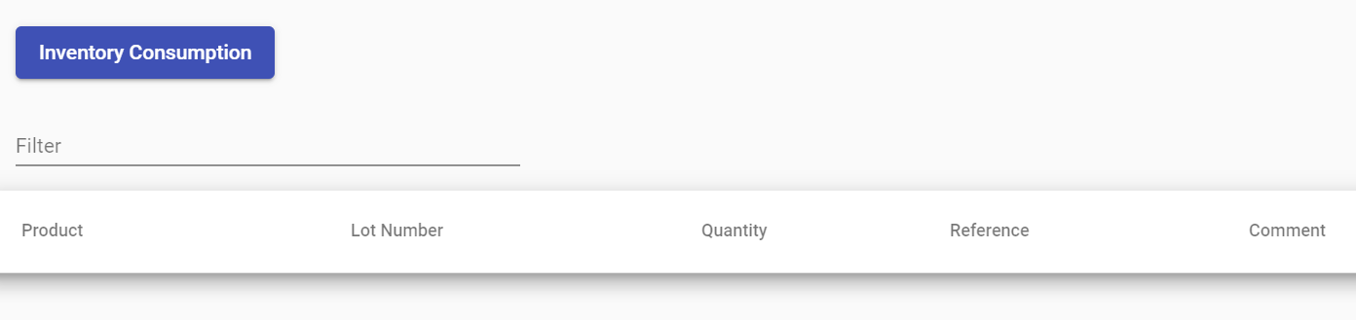

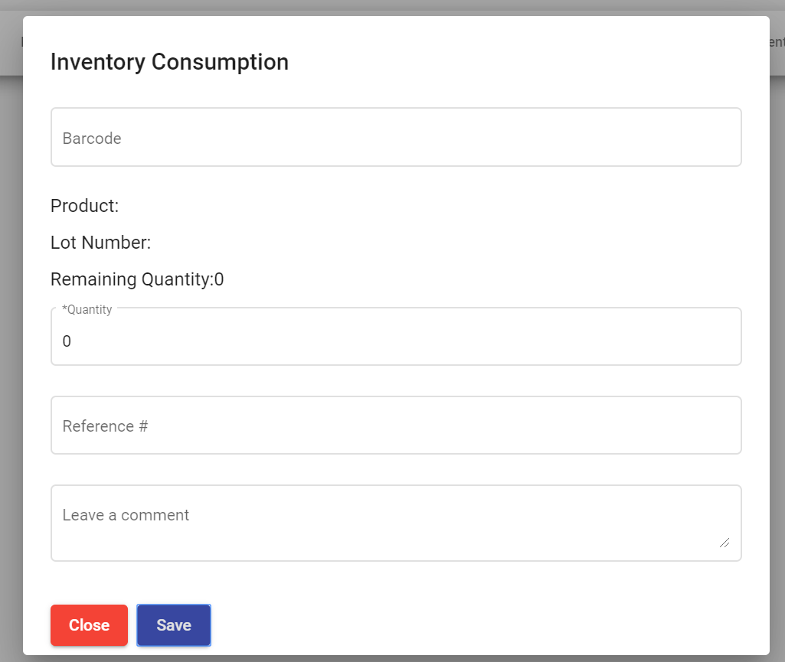

1. Inventory In Report

Select a Date Range and click the Generate Inventory In Report. Data will be display in the table.

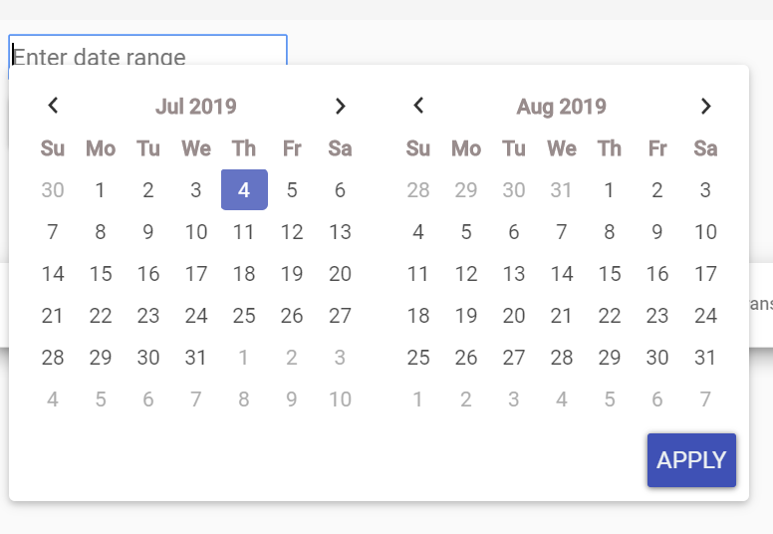

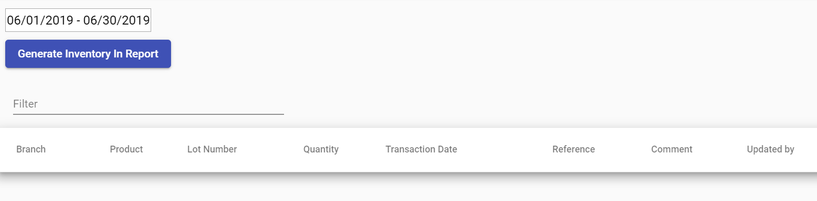

1. Inventory Out Report

Select a Date Range and click the Generate Inventory Out Report. Data will be display in the table.



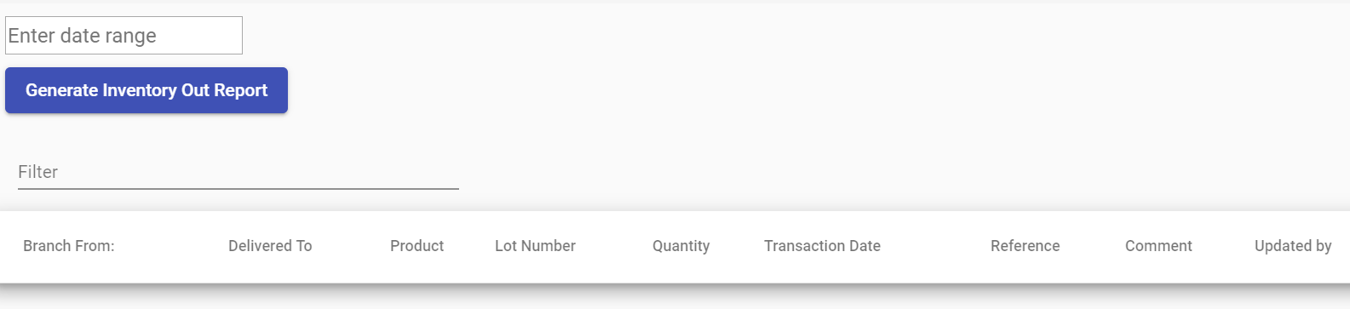

1. Inventory Adjustment Report

Select a Date Range and click the Generate Inventory Adjustment Report. Data will be display in the table.



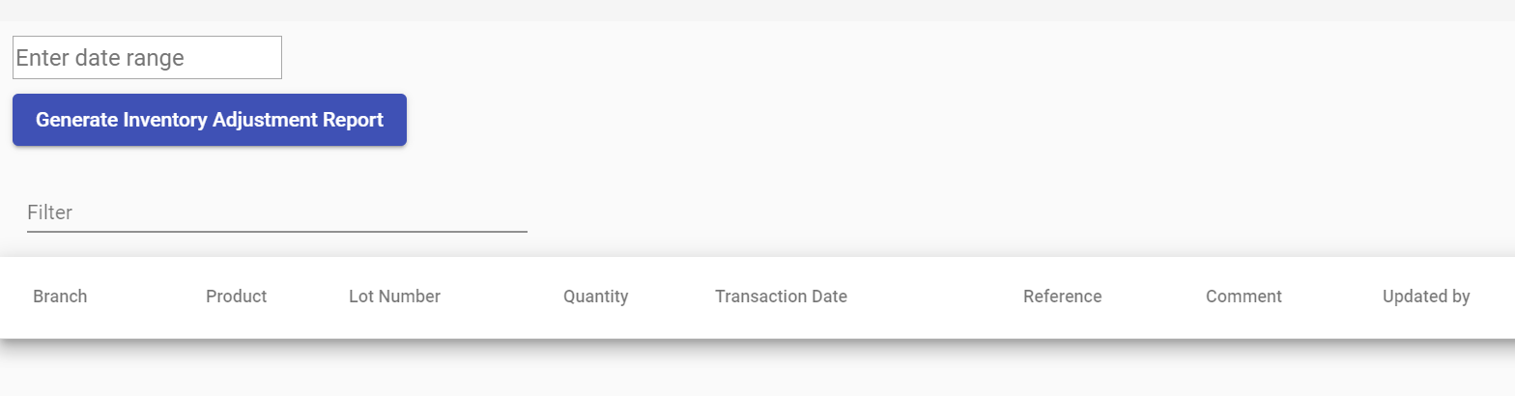

1. Inventory Consumption Report

Select a Date Range and click the Generate Inventory Consumption Report. Data will be display in the table.



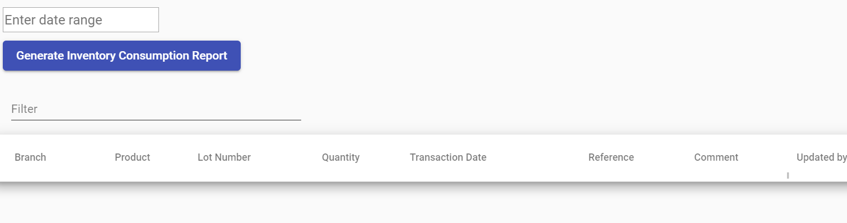

1. Inventory Report

Click the Generate Inventory Report. Data will be display in the table.

